ROSPL REPORT

## OPEN SOURCE CONTRIBUTION:

Participating in open-source projects involves actively engaging in the development and enhancement of publicly accessible software. In open-source development, the software's source code is made available to the public, allowing anyone to view, use, modify, and distribute it. The core principles of open source revolve around transparency, collaboration, and community-driven innovation.

Open-source software offers users the freedom to use, study, modify, and distribute its source code. This source code, written in programming languages such as Python, JavaScript, C++, etc., can be run and altered by users, provided they adhere to the open-source license terms governing the project.

Contributing to open-source projects is crucial for the continued growth and sustainability of the software. These projects often begin small, initiated by individual developers or small teams. As they gain popularity, they attract more users and, consequently, more issues, bug reports, and feature requests. Contributing to these projects enables developers to address these challenges, making the software more resilient and feature-rich.

## TYPES OF OPEN SOURCE CONTRIBUTIONS:

* Contributions to open-source projects manifest in various forms, allowing individuals to participate based on their skills and interests. Common types of contributions include:
* Code Contributions: Creating new code or modifying existing code to fix bugs, introduce new features, enhance performance, or improve functionality.
* Documentation: Creating or improving project documentation, including installation guides, user manuals, and developer guides. Well-maintained documentation is crucial for users and developers to effectively use the software.
* Bug Reporting and Issue Triage: Identifying and reporting software bugs or issues, providing details on how to reproduce them. Additionally, contributors can assist in managing issues by verifying bugs, proposing solutions, or prioritizing them for developers.
* Testing and Quality Assurance: Conducting tests on the software to ensure it behaves as expected, avoiding the introduction of new bugs or regressions.

## IMPACT OF OPEN SOURCE CONTRIBUTIONS:

Open-source contributions have wide-ranging effects on the software community and beyond:

* Advancement of Technology: Open-source projects often introduce new technologies, libraries, and tools that influence the broader tech industry.
* Accessibility and Inclusivity: Open-source software is typically freely available, promoting accessibility for users worldwide. The open nature of these projects encourages diverse participation, making them more inclusive.
* Knowledge Sharing: Contributors share knowledge and collectively improve their skills through contributions and community interactions.
* Collaborative Learning: Participation in open-source projects exposes developers to best practices, code reviews, and collaboration, enhancing their understanding of software development.
* Secure and Reliable Software: The collective efforts of contributors lead to rigorous testing, early bug detection, and faster issue resolutions, resulting in more secure and reliable software.

## SELECTION OF REPOSITORIES:

* We have chosen repositories primarily from the domains of web development and Java- related fields. These selections are based on the belief that issues related to web development are easily noticeable and can affect user experiences. By contributing to these repositories, we aim to help fellow community members while benefiting from the learning opportunities and the satisfaction of making a positive impact. Our comfort and expertise in web development and Java make these fields a natural choice for our contributions, and we are pleased to see some of our contributions being accepted by the repository owners. This experience has been enriching, fostering our growth as developer

# CONTRIBUTIONS:

## REPOSITORY 1:

**LINK**: <https://github.com/shikaruki/Hactoberfest2021>

Solved:-

https://github.com/Anamaya1729/Hactoberfest2022/compare/main...anjipunsi:Hactoberfest2022:main

## ISSUE:

To create a Dictionary and display the items

## CODE CHANGED:

# Creating an empty Dictionary Dict = {}

print("Empty Dictionary: ") print(Dict)

# Creating a Dictionary # with dict() method

Dict = dict({1: 'Geeks', 2: 'For', 3: 'Geeks'}) print("\nDictionary with the use of dict(): ") print(Dict)

# Creating a Dictionary

# with each item as a Pair

Dict = dict([(1, 'Geeks'), (2, 'For')]) print("\nDictionary with each item as a pair: ") print(Dict)

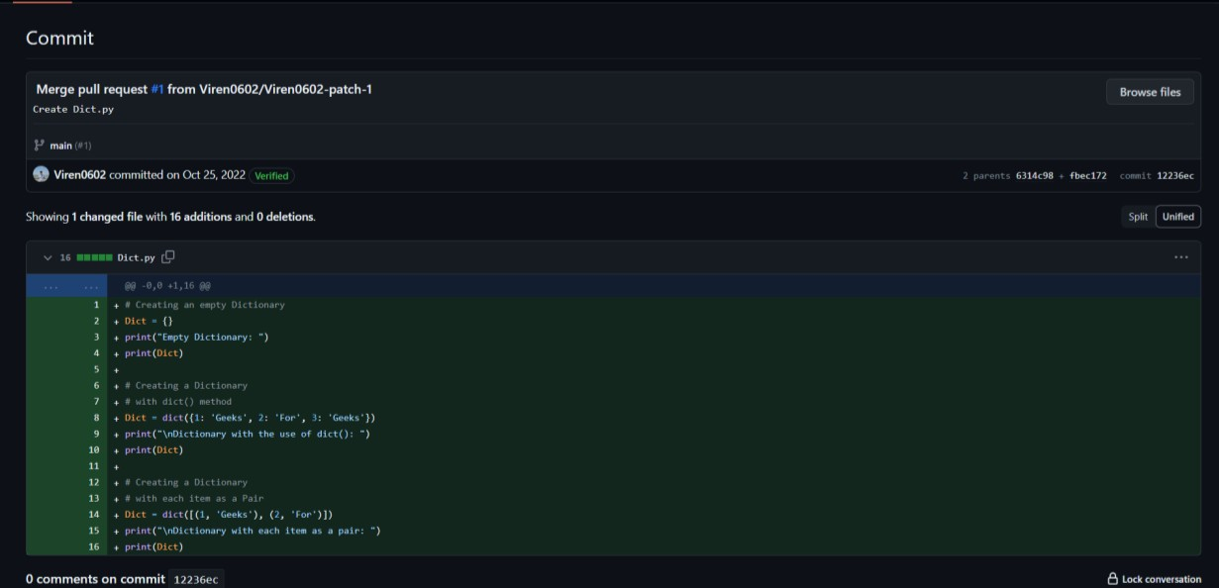

**Fig. 1.1** CODE ADDED

# CONTRIBUTIONS:

## REPOSITORY 2:

**LINK:**

<https://github.com/keshavsingh4522/hacktoberfest2021c>

solved:-

https://github.com/Anamaya1729/Hactoberfest2022/compare/main...anjipunsi:Hactoberfest2022:main

**ISSUE**: To Create an Calculator app

## CODE CHANGED:

<!DOCTYPE html>

<html>

<head>

<script src=

"https://cdnjs.cloudflare.com/ajax/libs/mathjs/10.6.4/math.js" integrity=

"sha512- BbVEDjbqdN3Eow8+empLMrJlxXRj5nEitiCAK5A1pUr66+jLVejo3PmjIaucRnjlB0P9R3r BUs3g5jXc8ti+fQ=="

crossorigin="anonymous" referrerpolicy="no-referrer"></script>

<script src=

"https://cdnjs.cloudflare.com/ajax/libs/mathjs/10.6.4/math.min.js" integrity=

"sha512- iphNRh6dPbeuPGIrQbCdbBF/qcqadKWLa35YPVfMZMHBSI6PLJh1om2xCTWhpVpmUy b4IvVS9iYnnYMkleVXLA=="

crossorigin="anonymous" referrerpolicy="no-referrer"></script>

<!-- for styling -->

<style> table {

border: 1px solid black;

margin-right: auto;

}

input[type="button"] { width: 100%; padding:

20px 40px;

<tr>

<!-- create button and assign value to each button -->

<!-- dis("1") will call function dis to display value -->

<td><input type="button" value="1" onclick="dis('1')" onkeydown="myFunction(event)"> </td>

<td><input type="button" value="2" onclick="dis('2')" onkeydown="myFunction(event)"> </td>

<td><input type="button" value="3" onclick="dis('3')" onkeydown="myFunction(event)"> </td>

<td><input type="button" value="/" onclick="dis('/')" onkeydown="myFunction(event)"> </td>

</tr>

<tr>

<td><input type="button" value="4" onclick="dis('4')" onkeydown="myFunction(event)"> </td>

<td><input type="button" value="5" onclick="dis('5')" onkeydown="myFunction(event)"> </td>

<td><input type="button" value="6" onclick="dis('6')" onkeydown="myFunction(event)"> </td>

<td><input type="button" value="*" onclick="dis('*')" onkeydown="myFunction(event)"> </td>

</tr>

<td><input type="button" value="8" onclick="dis('8')" onkeydown="myFunction(event)"> </td>

<td><input type="button" value="9" onclick="dis('9')" onkeydown="myFunction(event)"> </td>

<td><input type="button" value="-" onclick="dis('-')" onkeydown="myFunction(event)"> </td>

</tr>

<tr>

<td><input type="button" value="0" onclick="dis('0')" onkeydown="myFunction(event)"> </td>

<td><input type="button" value="." onclick="dis('.')" onkeydown="myFunction(event)"> </td>

<!-- solve function call function solve to evaluate value -->

<td><input type="button" value="=" onclick="solve()"> </td>

<td><input type="button" value="+" onclick="dis('+')" onkeydown="myFunction(event)"> </td>

</tr>

</table>

<script>

// Function that display value function dis(val) {

document.getElementById("result").value += val

}

function myFunction(event) {

if (event.key == '0' || event.key == '1'

|| event.key == '2' || event.key == '3'

|| event.key == '4' || event.key == '5'

|| event.key == '6' || event.key == '7'

|| event.key == '8' || event.key == '9'

|| event.key == '+' || event.key == '-'

|| event.key == '*' || event.key == '/') document.getElementById("result").value += event.key;

}

var cal = document.getElementById("calcu"); cal.onkeyup = function (event) {

if (event.keyCode === 13) { console.log("Enter");

let x = document.getElementById("result").value console.log(x);

solve();

}

}

// Function that evaluates the digit and return result function solve() {

let x = document.getElementById("result").value let y = math.evaluate(x) document.getElementById("result").value = y

}

// Function that clear the display function clr() {

document.getElementById("result").value = ""

}

</script>

</body>

</html>

## CODE ADDED

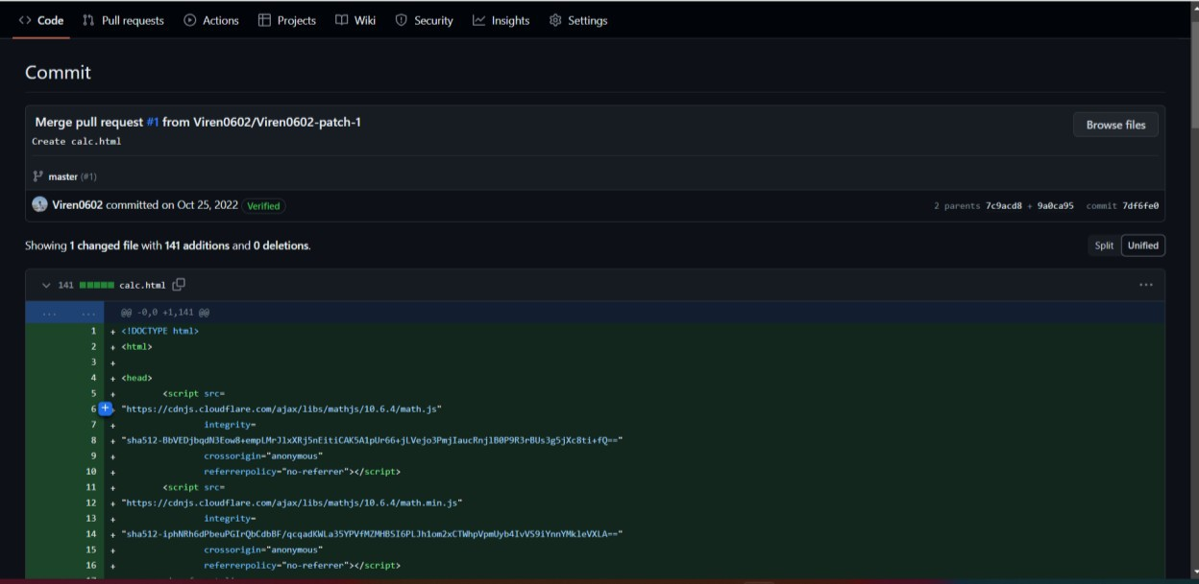

**Fig 2.1** Code Added

## REPOSITORY 3:

**LINK:** [https://github.com/Anamaya1729/Hactoberfest2022](https://github.com/Anamaya1729/Hactoberfest2022%20%09)

**ISSUE**: Program to display the Fibonacci sequence up to n-th term

Solved”:- https://github.com/anjipunsi/Hactoberfest2022/blob/main/fibonacci.py

## CODE CHANGED

nterms = int(input("How many terms? ")) # first two terms

n1, n2 = 0, 1

count = 0

# check if the number of terms is valid if nterms <= 0:

print("Please enter a positive integer") # if there is only one term, return n1 elif nterms == 1:

print("Fibonacci sequence upto",nterms,":") print(n1)

# generate fibonacci sequence else:

print("Fibonacci sequence:") while count < nterms: print(n1)

nth = n1 + n2

# update values n1 = n2

n2 = nth count += 1

# CODE ADDED

**Fig 3.1** Code Added

## REPOSITORY 4:

**LINK:** [**https://github.com/vikhyatsingh123/Naruto-Shippuden**](https://github.com/vikhyatsingh123/Naruto-Shippuden)

**https://github.com/vikhyatsingh123/Naruto-Shippuden/compare/main...anjipunsi:Naruto-Shippuden:main**

**ISSUE**: To write a code for adding two integers

## CODE CHANGED

<!DOCTYPE html>

<html>

<body>

<h2>Computer Code</h2>

<p>This is a programming code:</p>

<code>

x = 5;<br>

y = 6;<br>

z = x + y;

</code>

</body>

</html>

## CODE ADDED

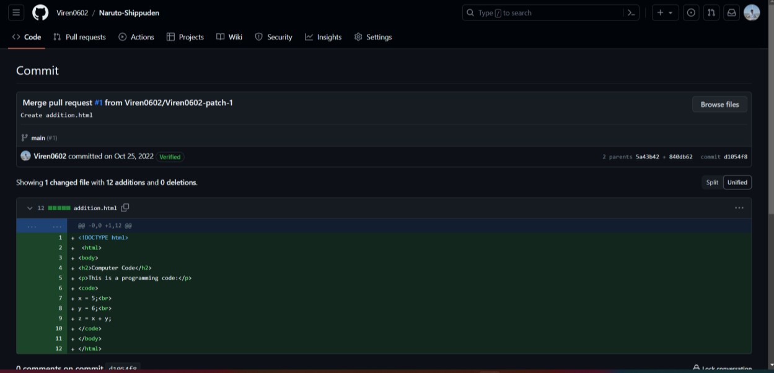

**Fig 4.1** Code Added

## REPOSITORY 5:

**LINK:** <https://github.com/python4geeks/Hactoberfest2022>

**ISSUE**: Program to check if a number is prime or not

## CODE CHANGED

num = 29

# To take input from the user

#num = int(input("Enter a number: ")) # define a flag variable

flag = False

# prime numbers are greater than 1 if num > 1:

# check for factors

for i in range(2, num):

if (num % i) == 0:

## CODE ADDED

**Fig 5.1** Code Added

## REPOSITORY 6:

**LINK:** <https://github.com/gdsc-uba/hactoberfest2022>

**ISSUE**: To create a t-shirt website

## CODE CHANGED

<!DOCTYPE html>

<html lang="en" dir="ltr">

<head>

<meta charset="utf-8" />

<title>T-Shirt</title>

<link rel="icon" type="image/x-icon" href="tshirt1.ico" />

</head>

<style media="screen"> body {

background-image: linear-gradient(to right, rgb(172, 194, 193),

rgb(180, 172, 194));

}

h3 {

color: black;

font-family: "Source Sans Pro", sans-serif; font-size: 25px;

text-decoration-line: underline;

}

select.size {

width: 70px; height: 30px;

}

select.quantity { width: 70px; height: 30px;

}

label.color { width: 70px; height: 30px;

}

h1 {

color: rgb(28, 30, 36); text-align: center; border: 1.5px solid; box-shadow: 2px 6px; background: white;

font-family: "Rubik", sans-serif;

}

</style>

<body>

<center>

<h1>Online Shopping Website</h1>

<!-- </center> -->

<form name="myForm" id="shirt_cart" onsubmit="return validateForm()" enctype="multipart/form-data" method="put">

<br>

<br>

<label for="name"> Enter your Name: - </label>

<input type="text" id="name" />

<br />

<br />

<label for="email">EMAIL:-</label>

<input type="email" name="email" id="email" /><br /><br />

<label for="tel">Contact:-</label>

<input type="tel" name="tel" id="tel" maxlength="10" minlength="6" /><br /><br />

<label for="Address"> Enter your Shipping Address : - </label>

<textarea id="Address"></textarea>

<br />

<br />

<label for="tagline"> Enter Tagline:- </label>

<input type="text" id="tagline" minlength="1" maxlength="15" />

<br />

<br />

<label for="color"> select color:-</label>

<input type="color" id="color" />

<br />

<br />

<label for="size"> Choose The Size : -</label>

<select name="size" id="size">

<option value="Small">S</option>

<option value="Medium" selected>M</option>

<option value="Large">L</option>

<option value="Extra Large">XL</option>

</select>

<br />

<br />

<label for="quantity"> Enter quantity:- </label>

<input type="number" id="quantity" min="1" max="9" />

<br />

<br />

<label for="deldate"> Enter Date to be Delivery:- </label>

<input type="Date" id="deldate" />

<br />

<br />

<b>Select Your Payment Option:-</b><br /><br />

<input type="radio" id="cod" name="payment" value="cod" />

<label for="cod" title="cash on delivery">COD</label><br /><br />

<input type="radio" id="upi" name="payment" value="upi" />

<label for="upi">UPI</label><br /><br />

<input type="radio" id="net" name="payment" value="net" />

<label for="net">Net Banking</label><br /><br />

<br />

<input type="submit" value="place Order" />

<input type="reset" value="reset" />

<br />

<br />

</center>

</form>

<script>

function validateForm() {

// Part A

const values = [ document.forms["myForm"]["tagline"].value, document.forms["myForm"]["color"].value, document.forms["myForm"]["size"].value, document.forms["myForm"]["payment"].value,

];

const hasEmptyFields = Object.values(values).some( (element) => element === ""

);

if (hasEmptyFields) { alert("Please fill in all fields"); return;

} // Part B document.getElementById("tagline").value = ""; var ele = document.getElementsByName("color");

for (var i = 0; i < ele.length; i++) ele[i].checked = false; var ele = document.getElementsByName("payment"); for (var i = 0; i < ele.length; i++) ele[i].checked = false;

const receipt_formatted = `Thank you for shopping!\nHere's your

receipt:\nDate: ${new Date().toLocaleDateString("UK")}\nTagline: ${values[0]

}\nColor: ${values[1]}\nSize: ${values[2]}\nPayment Method: ${values[3]

}`; alert(receipt_formatted);

}

const form = document.getElementById("shirt_cart"); form.addEventListener("submit", (event) => {

// stop form submission event.preventDefault();

});

</script>

</body>

</html>

## CODE ADDED

**Fig 6.1** Code Added

## REPOSITORY 7:

**LINK:** <https://github.com/theutpal01/HacktoberFest2022>

Solved:-

[Comparing theutpal01:master...anjipunsi:master · theutpal01/HacktoberFest2022 (github.com)](https://github.com/theutpal01/HacktoberFest2022/compare/master...anjipunsi:HacktoberFest2022:master)

**ISSUE**: To create an Alarm Clock

## CODE CHANGED

from tkinter import * import datetime import time

import winsound

from threading import * # Create Object

root = Tk()

# Set geometry root.geometry("400x200") # Use Threading

def Threading() t1=Thread(target=alarm)

t1.start() def alarm():

# Infinite Loop while True:

# Set Alarm

set_alarm_time = f"{hour.get()}:{minute.get()}:{second.get()}" # Wait for one seconds

time.sleep(1)

# Get current time

current_time = datetime.datetime.now().strftime("%H:%M:%S") print(current_time,set_alarm_time)

# Check whether set alarm is equal to current time or not if current_time == set_alarm_time:

print("Time to Wake up") # Playing sound

winsound.PlaySound("sound.wav",winsound.SND_ASYNC) # Add Labels, Frame, Button, Optionmenus

Label(root,text="Alarm Clock",font=("Helvetica 20 bold"),fg="red").pack(pady=10) Label(root,text="Set Time",font=("Helvetica 15 bold")).pack()

frame = Frame(root) frame.pack()

hour = StringVar(root)

hours = ('00', '01', '02', '03', '04', '05', '06', '07',

'08', '09', '10', '11', '12', '13', '14', '15',

'16', '17', '18', '19', '20', '21', '22', '23', '24'

)

hour.set(hours[0])

hrs = OptionMenu(frame, hour, *hours) hrs.pack(side=LEFT)

minute = StringVar(root)

minutes = ('00', '01', '02', '03', '04', '05', '06', '07',

'08', '09', '10', '11', '12', '13', '14', '15',

'16', '17', '18', '19', '20', '21', '22', '23',

'24', '25', '26', '27', '28', '29', '30', '31',

'32', '33', '34', '35', '36', '37', '38', '39',

'40', '41', '42', '43', '44', '45', '46', '47',

'48', '49', '50', '51', '52', '53', '54', '55',

'56', '57', '58', '59', '60')

minute.set(minutes[0])

mins = OptionMenu(frame, minute, *minutes) mins.pack(side=LEFT)

second = StringVar(root)

seconds = ('00', '01', '02', '03', '04', '05', '06', '07',

'08', '09', '10', '11', '12', '13', '14', '15',

'16', '17', '18', '19', '20', '21', '22', '23',

'24', '25', '26', '27', '28', '29', '30', '31',

'32', '33', '34', '35', '36', '37', '38', '39',

'40', '41', '42', '43', '44', '45', '46', '47',

'48', '49', '50', '51', '52', '53', '54', '55',

'56', '57', '58', '59', '60')

second.set(seconds[0])

secs = OptionMenu(frame, second, *seconds) secs.pack(side=LEFT)

Button(root,text="Set Alarm",font=("Helvetica 15"),command=Threading).pack(pady=20) # Execute Tkinter

root.mainloop(

## CODE ADDED

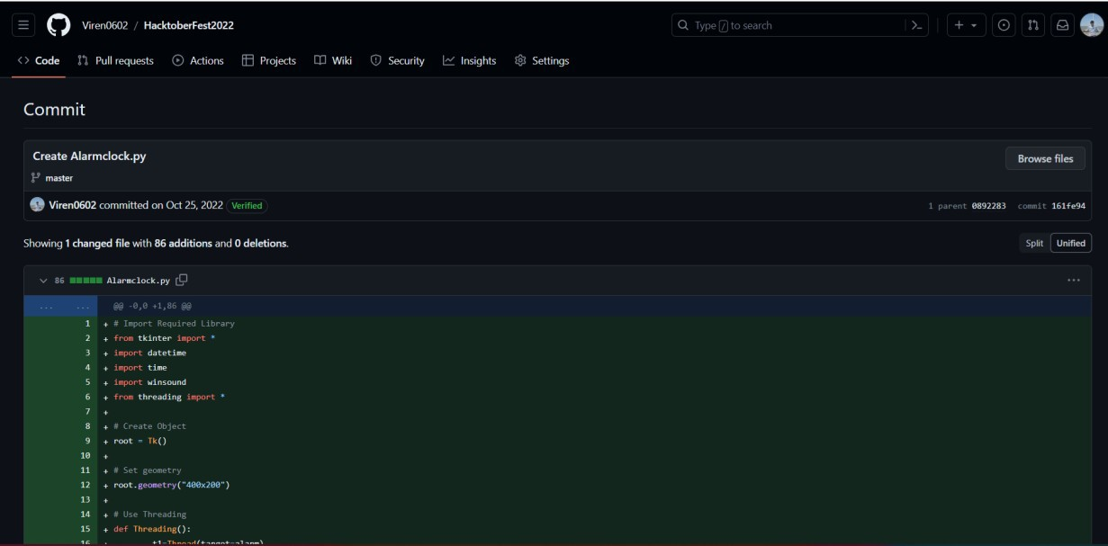

**Fig 7.1** Code Added

## REPOSITORY 8:

**LINK:** <https://github.com/areebhammad/HF2022>

Solbved: areebhammad/HF2022:

**ISSUE**: ScrollBar not visible

## CODE CHANGED

::-webkit-scrollbar

width: 20px; width: 2px;

}

::-webkit-scrollbar-thumb

{

## CODE ADDED

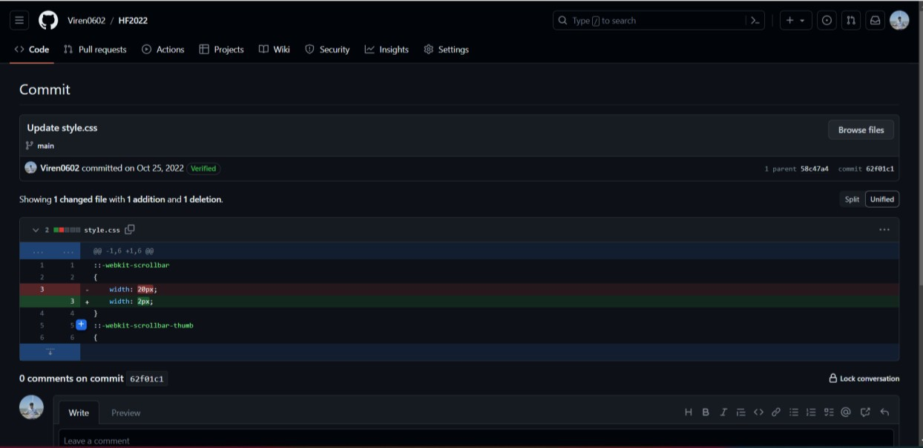

**Fig 8.1** Code Added

## REPOSITORY 9 :

**LINK**: <https://github.com/Yash-srivastav16/Tour-Project>

Solved:-

<https://github.com/anjipunsi/Tour-Project/tree/main/css>

## ISSUE:

Search Bar Not Loading

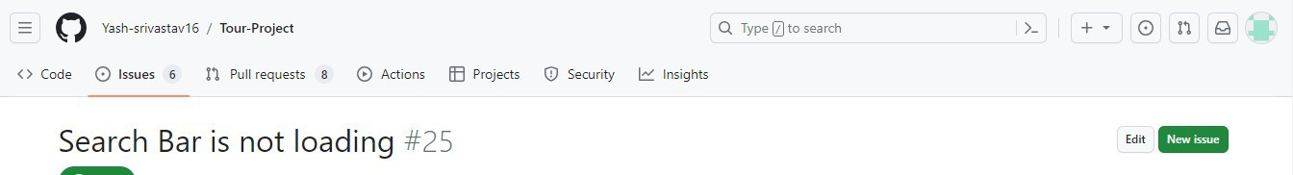

## BEFORE:



AFTER:



## CODE CHANGED:

<div class="icons">

<div id="menu-btn" class="fas fa-bars"></div>

<div id="search-btn" class="fas fa-search"></div>

</div>

</header>

<div class="search-form">

<div id="close-search" class="fas fa-times"></div>

<form action="">

<input type="search" name="" placeholder="search here..." id="search-box">

<label for="search-box" class="fas fa-search"></label>

</form>

</div>

## CODE ADDED

**Fig 9.1** Code Added

## REPOSITORY 10:

**LINK:** <https://github.com/bhupendra-chauhan02/FitnessWebsite>

Solved: [FitnessWebsite/Home page at main · anjipunsi/FitnessWebsite (github.com)](https://github.com/anjipunsi/FitnessWebsite/blob/main/Home%20page)

**ISSUE**: Add an about page to the website describing more about the gym

## CODE ADDED

<!DOCTYPE html>

<html lang="en">

<head>

<meta charset="UTF-8">

<meta name="viewport" content="width=device-width, initial-scale=1.0">

<title>Document</title>

<link rel="stylesheet" href="style.css">

</head>

<body>

<section class="about-section">

<div class="about-content">

<h2>About Us</h2>

<p>Welcome to HarryFitness, your ultimate destination for achieving your fitness goals and living a healthier life. We are a dedicated team of fitness enthusiasts, trainers, and wellness experts who are passionate about helping you transform your body and mind.</p>

<p>At HarryFitness, we believe that fitness is not just about lifting weights and running on a treadmill. It's a holistic journey towards overall well-being. Whether you're a beginner looking to kickstart your fitness journey or an experienced athlete aiming for peak performance, we have the right programs and support for you.</p>

<p>Our state-of-the-art gym is equipped with top-notch facilities, cutting-edge equipment, and a motivating environment to push your limits. Our certified trainers are here to guide you every step of the way, offering personalized workout plans, nutritional guidance, and constant motivation.</p>

</div>

<div class="topright flex justify-center">

<img src="gym.jpg" alt="About Us Image">

</div>

</section>

</body>

</html>

## CODE ADDED

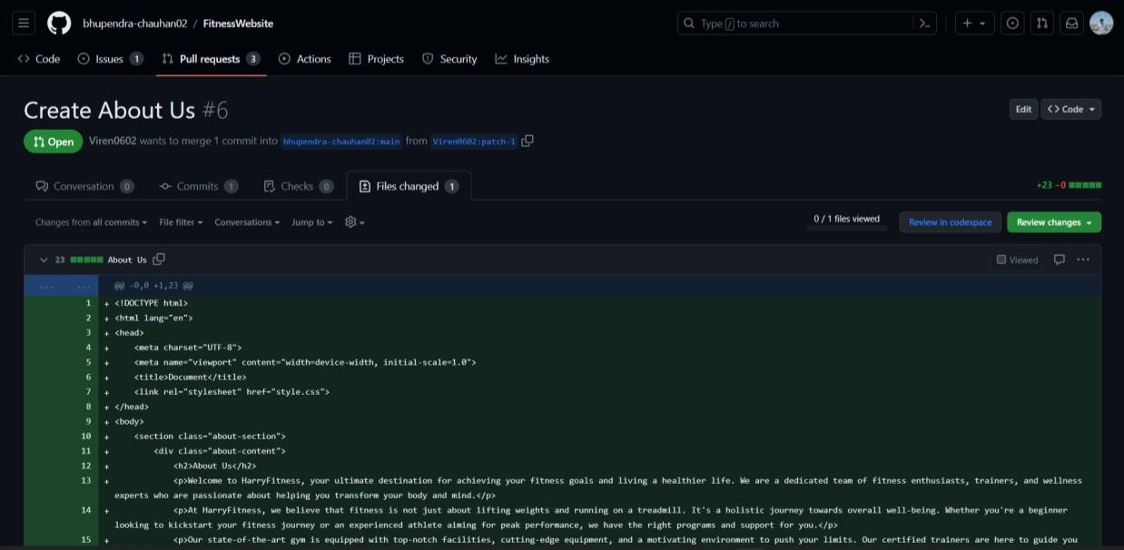

**Fig 10.1** Code Added

**AFTER**:

